Renju lesson on April 4, 2002

Hello everyone! Welcome to Online Renju Class. Last time we checked both 6-h7 and 6-j7, right? Today we will check the 6-h9 and 6-j9.

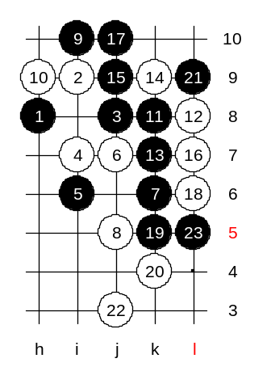
Oh Indeed. I missed that we had not checked the 12-outside. How many of you know win after this 12th move? It seems moves 14 and 16 are forced. Now (except tunnet), please everyone say your opinion for black's next move. Wow, so many good answers, 17-j10 indeed. White will take this natural L6 point. Now it is tough choice. Where should black defend now? All of you say L5. But why? White VCT? Where? Tunnet please show. As you see white has nothing. So, the fear of white's attack cannot be the reason why black should play 19-L5.
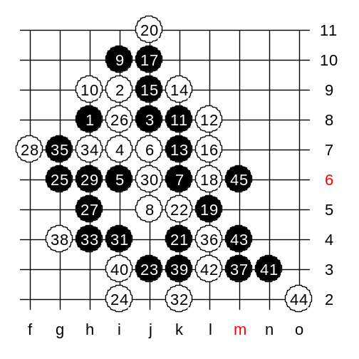
Move 18 is a provocation. In fact, white hopes that black would take the L9 point. Since white wants to defend in upper side anyway, like 20-k10, so the black's L9 stone will become a waste. Black will play 19-L7 not for defensive but for offensive reason! The connections to n7 or j3 will support black's attack a lot. Lets see how black uses this connection. The idea of k4 and j3 is that now white cannot play active k10, because of blacks VCF.

Scm200 shows the ending here, thanks!
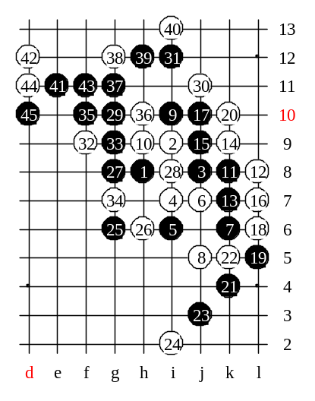

We check one more 20th move before we go on with another 6th move. The rest of the variants you can check by yourself at home.

Move 6-h9 will be easier, dont worry. :)
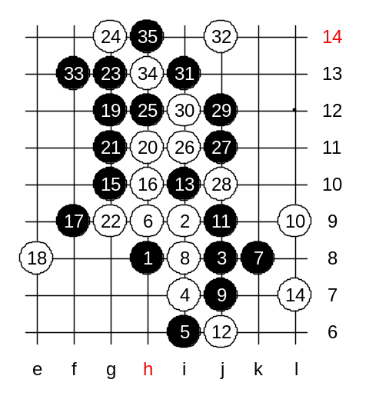
Where is the logical continuation from move 15? Move 15-g10 is very good here! The idea is to develop to the left side space, of course, and connect with lower side force. Move 16-j10 is really poor and black wins immediately with 17-g9. In our variant black goes 17-f9 - probably the only way to win. I ask you, why didnt black play four to h11 first? The clear explanation should be: Black cannot win by taking both h11 and f9 because it creates two white defensive stones. Black can play just f9 and use following tactics - if white blocks at h11 then space move to left, if white defends at e8 then black uses the g12 four later. Now, about 18th move, what if white plays to h11, what will be your space move? All the mentioned moves are GOOD and likely win fast! :) Congratulations to all who responded.
It seems that in case of 18-e8 black has VCT. Can you show?
Moocheng shows the ending,thanks!
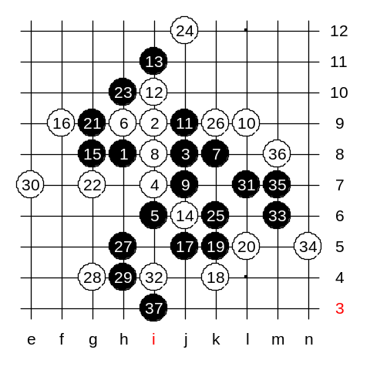
White's 12-i10 is very strong. I introduce the long variant, with less comments, to save our lesson time. If you have any questions about any of the moves in variant, you can ask anytime after we end the main variant.
Move 29- Two wins, how to block? Move 37 is win!

Ok, we do like this, if you have any questions about any move between 16...37, then prepare your questions by the beginning of next lesson and we check together, ok?
And now, we will end today's lesson, thank you all for coming, and we will meet again next week! Have a good week! :))

